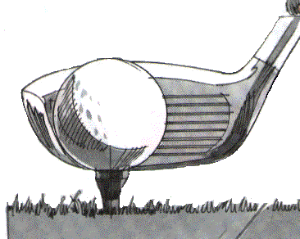

## Colourists’ Golf Day

Formerly SDC and OCCA

ANNUAL GOLF MATCH

**Friday 5 July 2019**

**AT**

**BRADLEY PARK GOLF CLUB, HUDDERSFIELD**

**(NORTH OF THE A6107)**

Your continued support for this event will be greatly appreciated

Beginners welcome

The tee is reserved from 1.00-2.00pm and the fee is £25.00 per head, to include Green Fee, sweep prizes and a 3-course meal. Members wishing to attend the dinner only will be welcome at a cost of £10 per head. Coaching available 11-12 am on request. Max Handicap 20.

Please note jacket and tie may be worn in the dining area after the game. Full Club facilities are at your disposal.

If you wish to play please complete the bottom portion of this form and return it to me at Town End (Leeds) plc with your remittance by 1 July 2019

Richard M Booker

### Colourists Golf Match – Friday 5 July 2019

Please reserve………………………..places(s) for the event

Name in Block letters …………………………………………….. Handicap*…………………..

*if applicable

Address ……………………………………………..

……………………………………………..

…………………..

Contact Telephone ……………………………………………..

I/We will require ……Meals

.Coaching available 11-12 am Yes/ No Please indicate

I have the following dietary needs…………………………………………………………………….

I enclose payment of……………………………………(made payable to Town End (Leeds) plc)

Please detach and return to: Richard M Booker, Town End (Leeds) plc, Silver Court, Intercity Way, Stanningley, Leeds, LS13 4LY.

Telephone: 0113 256 4251 or Email: richardbooker@dyes.co.uk